Shravani

Step 1: Creating DataSet by creating new Data Source for the Database NorthWind using Data Sources Window.

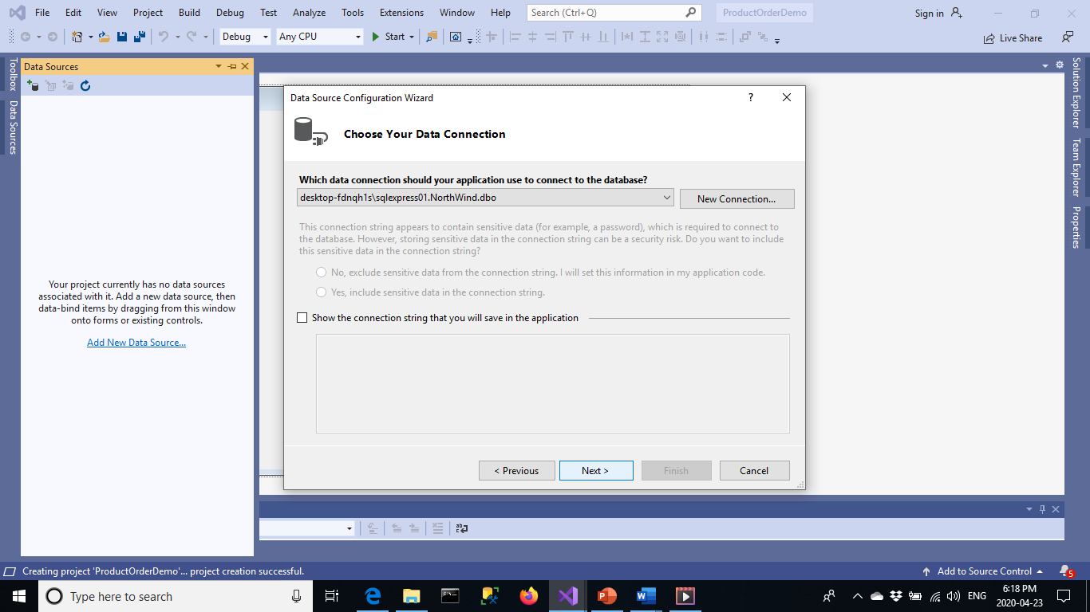

Step 2:

Choose Database objects. Selecting the required tables Products, OrderDetails, Suppliers( select only needed members like Id and companyname) , Categories (id,categoryname).

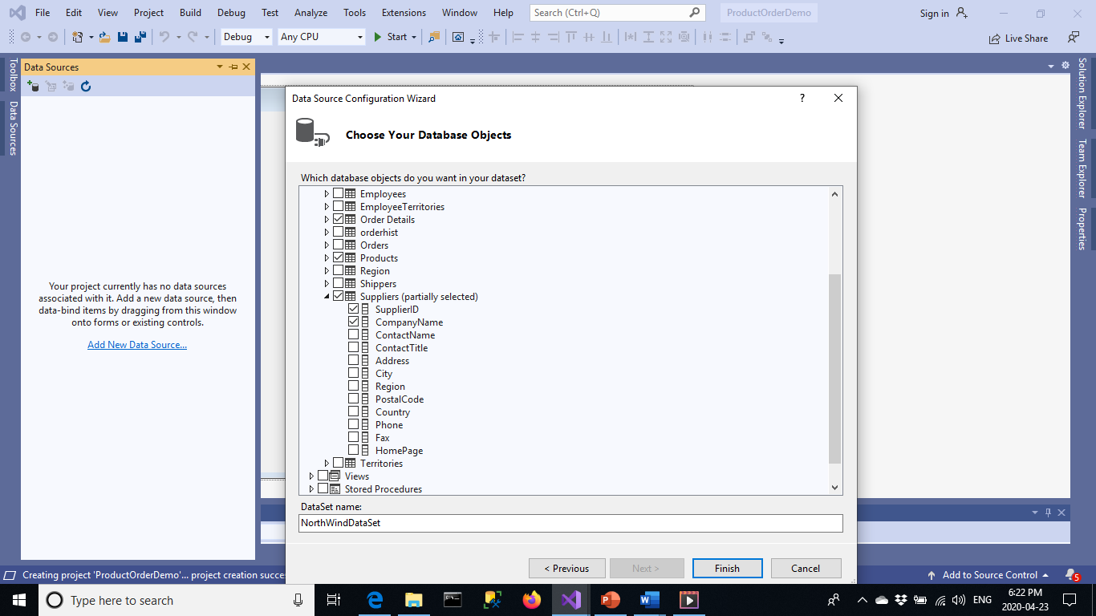

Step 3: Change the view of Products table from Data Grid View to Details view. This helps in viewing one Product at a time in textboxes. Also select SupplierId and CategoryId to have combo box view instead of textbox view. Now drag-drop this Products view from Datasource window on to the form’s deisgn.

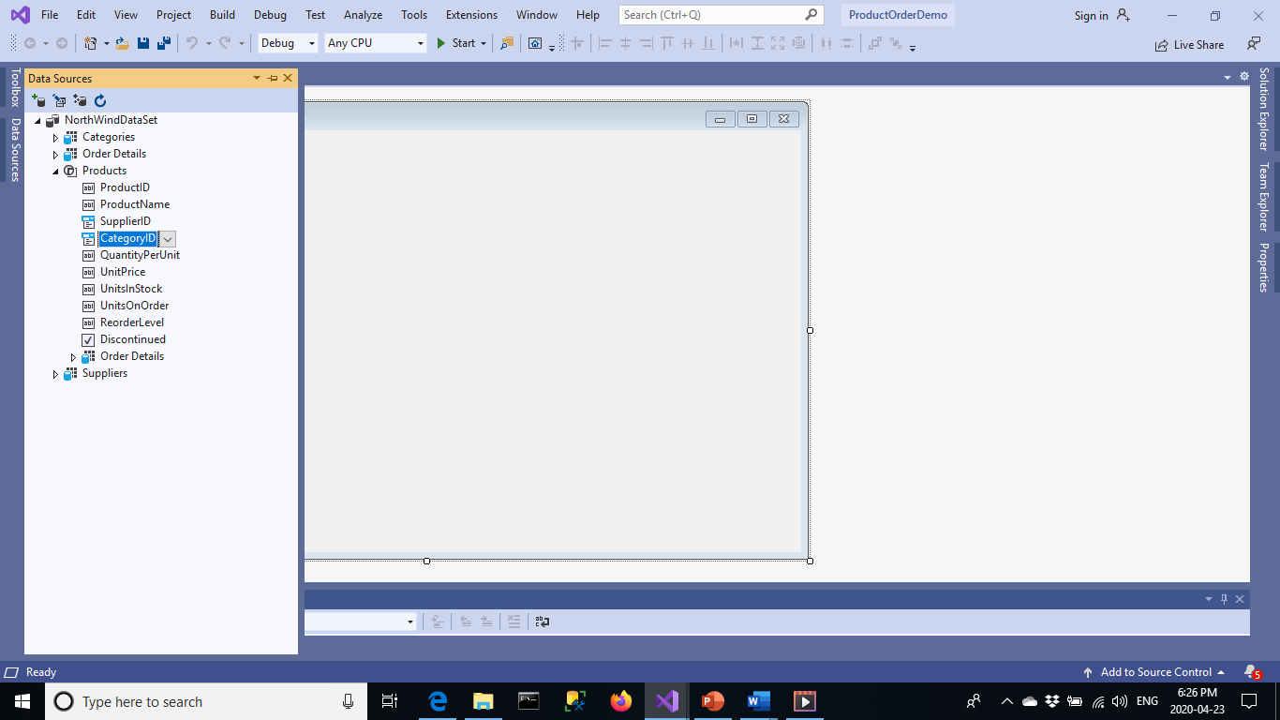

Step 4a:

Data bind the Supplier id and Category Id combo boxes to their respective tables.

Set Data source to their tables by giving appropriate display and value members.

Bind Selected Value for combo box to the Product table’s Supplier ID.

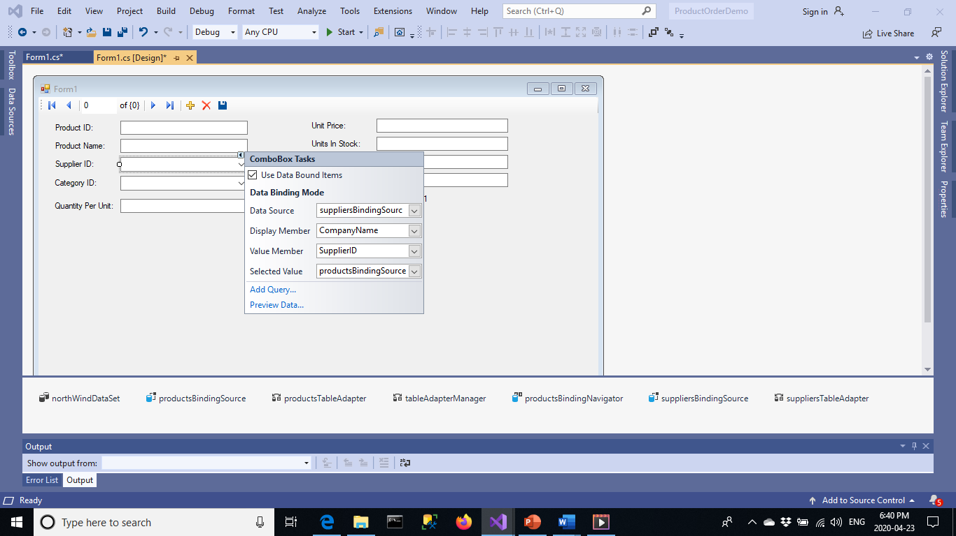

Step 4b:

Remove text from the dataBindings for both combo boxes to get the names displayed properly, with out displaying ID’s when form is loaded.

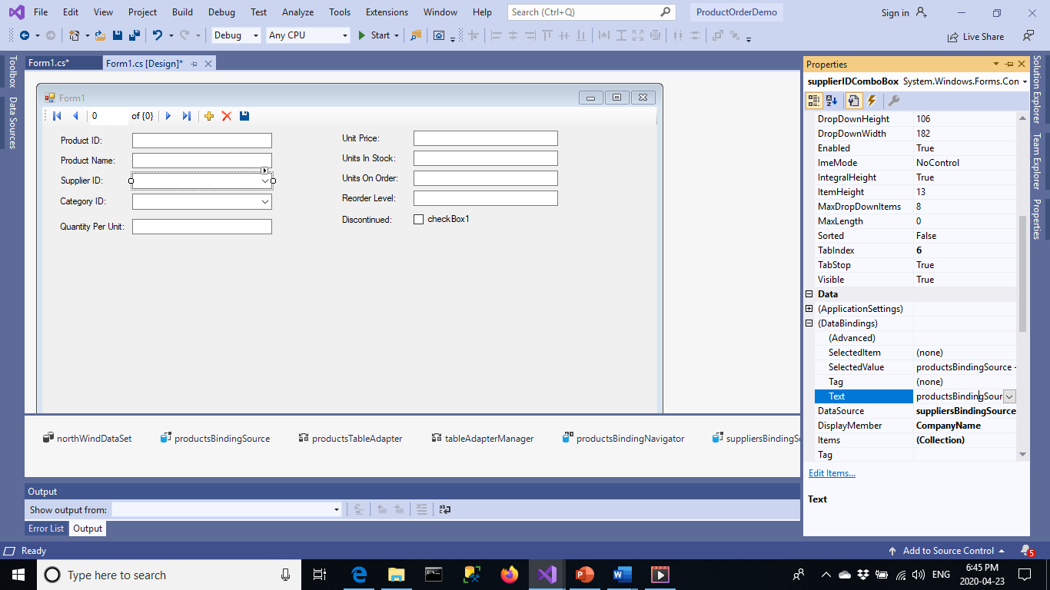

Output for displaying products:

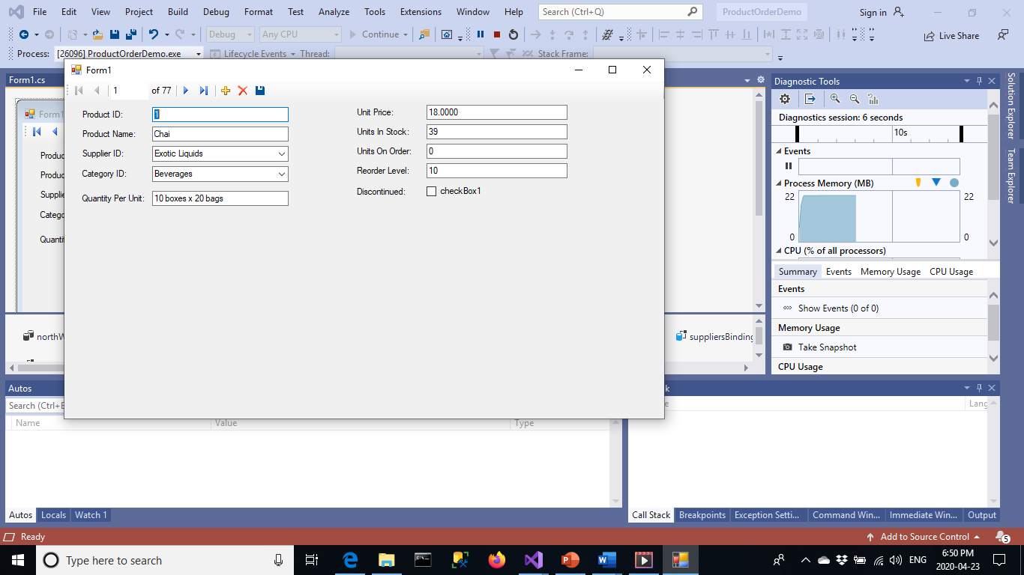

Step 5:

To display order details that are related to the current product, choose orderdetails data that are bound inside products dataset and not the order details data set which is by itself.

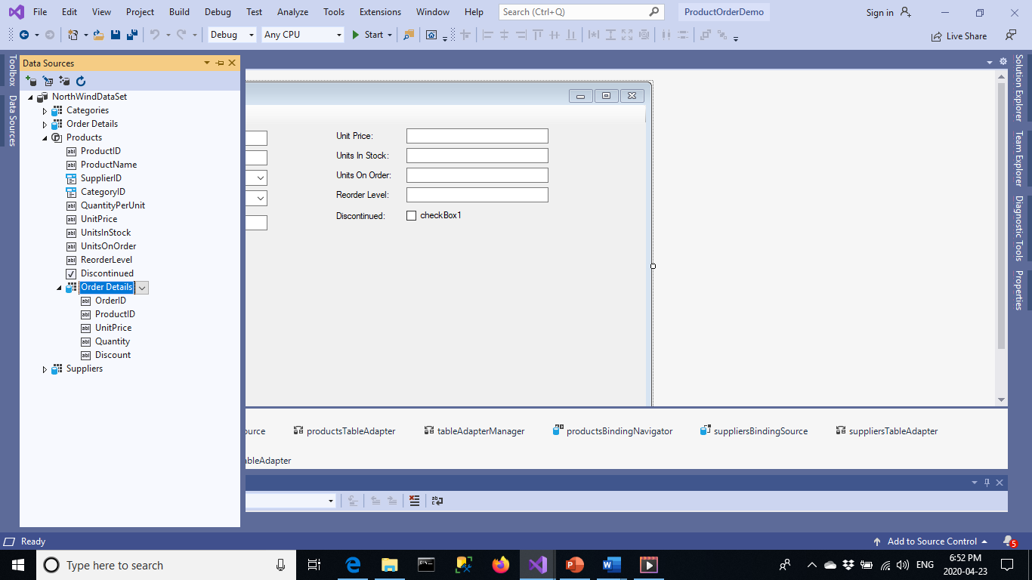

Step 6:

Make the Order Details grid read only by making the datagrid readonly property to true.